# As-Is

| **Actor** | **Activity** |
| --- | --- |
| User | Purchases item |
| Financial Institution | Provides account statements |
| User | Manually collects data from account statements (if at all) |
|  | Enters expenses manually into spreadsheet or notebook |
|  | Reviews data (typically at certain intervals throughout the week or month, if at all) |
| Support Resources | Consulted for budgeting advice(blogs, advisors, etc.) |
| User | Adjusts behavior after review |

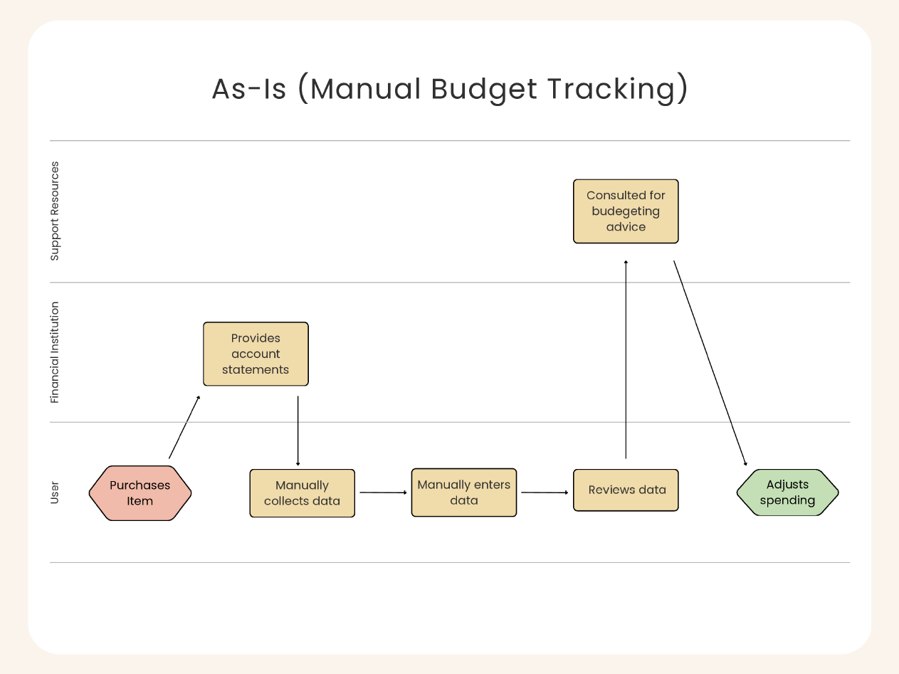

# To-Be

| **Actor** | **Activity** |
| --- | --- |
| User | Purchases item |
|  | Logs into SmartBudget (process initiation) |
| SmartBudget | Pulls/receives data (manual input or automatic sync) |
| Financial Institution | Sync updates expense data, if connected |
| SmartBudget | Automatically categorizes and visualizes (through rules, updates made in real-time) |
|  | Monitors spending pattern (compares real-time data to set budget) |
|  | Provides Tips or Alerts (notifies for overspending or actionable advice) |
| User | Proactively reacts to adjust spending before overspending occurs |

